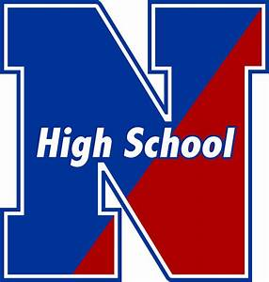NESHAMINY HIGH SCHOOL

ATHLETIC DEPARTMENT

Spring 2025 Athletic Registration Checklist

Please see below for the proper steps needed to participate in athletics for Neshaminy High School for the Spring 2025 season.

□ **FamilyID:**

* Log in to your Arbiter Registration (FamilyID) account if you have registered before OR create an Arbiter Registration (FamilyID) account if you have NEVER registered before. **(DO NOT CREATE A NEW ACCOUNT)**
* Register for the sport you intend to participate in/tryout for.
* Fill out all the information asked and submit when finished.
* [**https://students.arbitersports.com/neshaminy-high-school-athletic-and-co-curricular-department/spring-2025-athletic-registration-3**](https://students.arbitersports.com/neshaminy-high-school-athletic-and-co-curricular-department/spring-2025-athletic-registration-3)

□ **Physicals:**

* **Sections 1-6** of the PIAA Comprehensive Initial Pre-Participation Physical Examination form must be completed, signed by a doctor, and turned into the Athletic Trainer or Athletic Office prior to **February 24, 2025**.
  + If you already turned in a physical for the fall or winter sports season you only need to submit Section 7 (Re-Certification by Parent or Guardian).
* Physical (Section 6) **MUST** be dated on Section 6 after **May 1, 2024,** and **MUST** have a doctor’s signature.
* Turning in a physical after the above dates for your sport, risk not being eligible to participate on the first day of tryouts.
* <https://www.piaa.org/assets/web/documents/PIAA_CIPPE_FORMS_SECTION(S)_1_-_10(1).pdf>

□ **Concussion Education and Baseline Testing:**

* **Volleyball, Baseball, Softball, and Lacrosse athletes** must complete required Concussion Education and Baseline Testing.
* **If you completed the concussion education/baseline testing in the fall or winter you DO NOT need to complete it again!**
* Reach out to your coach for this information!
* **PART 1 (GOOGLE FORM EDUCATION) AND PART 2 (BASELINE TEST) MUST BE COMPLETED TO BE ELIGIBLE TO PARTICIPATE!**